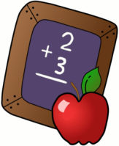
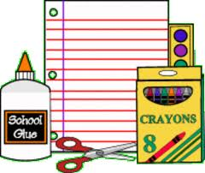
Reyes Elementary School
Pre-Kinder
Supply List –Lista de materiales

- 2-boxes of big crayons (8 count) | - 2 Cajas de Crayolas
- 1 Box of washable markers | - 1 caja de marcadores lavables
- 2 bottles of medium glue | - 2 botellas medianas de pegamento
- 1 medium backpack to fit a notebook that will be sent home daily | - 1 mochila mediana donde quepa una carpeta que se llevara acasa diariamente
- 1 optional, change of clothes (Pants, underwear and socks) | - 1 (opcional) cambio de ropa(pantalón, calzoncillo y calcetines)
- 1 watercolors Paint box | - 1 caja de pinturas de acuarelas
- 2 plastic folder with pockets | - 2 carpetas de plástico con bolsitas
- 1 ream of White paper | - 1 paquete de papel para copiar
- 1 bottle of hand sanitizer | - 1 botella de desinfectante de manos
- 1 container of Clorox wipes | - 1 contenedor de toallitas de cloro
- 2 boxes of kleenex | - 2 cajas de kleenex
- 1 box of gallon size zip-lock bags | - 1 caja de bolsas zip-lock de capacidad de un galón
- 1 box of sandwich size zip-lock bags | - 1 caja de bolsas zop-lock con capacidad de sándwich
- 1 fiskar scissors | - 1 tijeras de la marca fiskar
- 1 set of 4 play-doh tubs | - 1 caja de 4 plastilinas
- 2 packets of 4 glue sticks | - 2 paquetes de 4 pegaduras en tubo

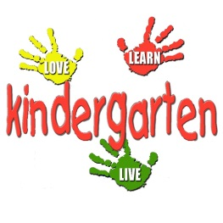
Reyes Elementary
2016-2017
Kindergarten Supply List
Lista de Útiles Para Kínder

1 school box (8x5)/ 1 caja para guardar útiles
1 pair of Fiskar scissors/ 1 par de Tijeras Fiskar
2 durable plastic pocket folders with prongs/2 carpetas de plastico con broches
4 boxes of thin Crayola brand crayons/4 cajas de colores de cera marca “Crayola”
4 bottles of all purpose glue Elmer’s Brand/4 botellas de pegadura liquida marca “Elmer’s”
2 large glue sticks Elmer’s Brand/2 tubos grandes de pegadura de barra marca “Elmer’s”
1 package of #2 wood pencils / 1 paquete de lápices #2 de madera
1 pair of headphones (no ear buds please)/ 1 par de audífonos grandes
2 regular composition notebooks/2 cuadernos de composición.
2 primary ruled composition notebook (Story paper)/2 cuadernos de composición
de regla primaria (Papel para escribir cuentos)
2 package of White copier paper/2 paquete de papel blanco para la copiadora
2 large boxes of Klennex tissues/2 cajas grandes de pañuelos desechables
2 large containers of disinfectant wipes/2 botellas de toallas desinfectantes
1 box of large Ziplock brand bags/1 paquete de bolsas tamano grande Ziplock
1 box of small sandwich Ziplock brand baggies/1 paquete de bolsitas tamano chico
1 yellow marker highlighter/1 marcador fluorescente Amarillo
1 pack of 4 Expo dry erase markers/ 1 paquete de marcadores borrables marca Expo
1 white eraser (Magic eraser Brand)/1 borrador blanco marca (Magic eraser)

*Parents attached are images of the school supplies requested. The reason certain brands are encouraged is because these brands last longer than other brands and therefore we will not need to replenish supplies as often.
Thank you for your support.
Kindergarten Teachers.

*Estimados padres de familia, detrás de esta lista están imagines de los útiles que estamos
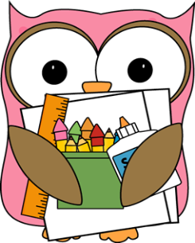
Pidiendo. La razón por la cual son recomendadas ciertas marcas en particular, es porque son más resistentes que otras marcas. Por lo mismo, no tendremos la necesidad de volver a pedir útiles tan seguido.

Gracias por su apoyo,
Atte,
Maestras de Kinder
Reyes Elementary School
1st Grade- 1er Grado
Supply List –Lista de materiales
- 4 boxes of Crayola crayons (24 count) | - 4 cajas de crayones (caja de 24)
- 1 box of 10 count washable markers | - Marcadores gruesos (caja de 10)
- 2 boxes of sharpened pencils (24 count) | - 2 cajas de 24 lápices con punta
- 1 set of water colors | - Acuarelas de pastilla
- Sharpener/ | - Sacapuntas
- 5 bottles of all-purpose Elmer’s Glue (no gel or washable) | - 5 botellas de pegamento marca Elmer’s Glue (no gel o lavables)
- 10 glue sticks | - 10 lápices adhesivos
- 5 Composition notebooks (NO SPIRAL NOTEBOOKS) | - 5 cuadernos de composición (pasta dura y de rayas) POR FAVOR NO MANDE CUADERNOS DE ESPIRAL.
- 1 ream of paper | - 1 paquete de hojas blancas
- 1 packet of wide ruled notebook paper | - 1 paquete de hojas de rayas
- 1 plastic folder with pockets and prongs | - 1 folder de plástico con bolsillos y agarraderas para hojas
- ½ inch 3 ring binder “Durable clear cover” | - 1 carpeta de ½ pulgada con bolsillo al frente
- 4 big erasers | - 4 borradores de goma
- 1 pack of pencil top erasers | - cajita de borradores individuales
- 2 pairs of scissors (Fiskar) | - 2 tijeras de punta redonda marca Fiskar
- 1 ruler (inches and centimeters) | - Regla de 12 pulgadas y que también traiga centímetros
- 2 pkgs. Expo dry erase markers | - 2 paquetes de marcadores “Dry-Erase” punta mediana
- 3 boxes of Klennex | - 3 cajas de Klennex
- 1 bottle of disinfecting wipes | - 1 bote de toallas húmedas “Cloro Desinfectantes”
- 1 box of gallon size Ziploc bags | - 1 caja de bolsas Ziploc de un galón
- 1 box quart size Ziploc bags | - 1 caja de bolsas Ziploc tamaño chicas
- 1 small school box (not a large size) | - 1 caja de plastico para colores y útiles (no grande)
- 1 pair of headphones (over the head NO ear buds) | - 1 par de audífonos
- Girls- 1 pack of Mr. Clean Magic Eraser
- Boys- 1 box of baby wipes | - 1 bote de toallitas húmedas “para bebe”

Reyes Elementary School
2nd Grade- 2do Grado
Supply List –Lista de materiales

- 2 boxes of 24 crayons (Crayola brand please) | - 1 pack of wide ruled paper
- 1 box of color pencils | - School agenda ca be purchased at school office
- 1 packet of EXPO dry erase markers | - 1 plastic folder with prongs and pockets
- 2 bottles of (8oz.) of all purpose Elmer’s Glue (no gel or washable please) | 12 glue sticks
- 10 Composition notebooks | - 2 spiral notebooks (wide rule 70 pgs)
- 2 jumbo stretchable book cover to pit 9” X 12” | - 1 3 ring binder (1 ½ inch)
- 1 large pink eraser
- 2 boxes of #2 yellow wooden pencils
- 2 pairs of scissors for children
- 2 boxes of Kleenex or Puffs Tissues
- 1 Small school box. Please do not use a large
- 1 highliter
- 1 sandwich size Ziploc bags
- 1 gallon size Ziploc bags
- Wooden ruler (inches and centimeters)
- 3 containers of Clorox Disinfecting Wipes
- 1 Travel plastic soap container
- Students will need a backpack to carry their supplies(No wheels please)
- 2 reams of white paper
- headphones
- 1 pencil sharpener
 | Please be sure your child’s school supplies are labeled with the child’s name, AND are replenished as needed during the school year. This will ensure that your child is comfortable knowing he or she is prepared and ready to learn.

Reyes Elementary School
3rd Grade- 3rd Grado
Supply List –Lista de materiales

Monolingual | Dual Language
- Ream of white paper | - Paquete de hojas de papel blanco
- Ream of colored paper | - Paquete de hojas de papel de color
- 1 box of crayons | - 1 caja de lápices de colores
- 1 box of color pencils | - 4 cajas de kleenex
- 4 boxes of pencils | - 2 cajas de 20 lápices
- 1 pack of wide ruled paper | - 1 paquete de hojas de raya ancha
- 1 box of markers | - 1 caja de marcadores
- 10 Glue sticks | - 10 barras de pegamento
- 2 Elmer’s Glue | - 2 botellas de pegamento liquido Elmer
- 1 set of headphones | - 1 par de audífonos
- 2 highlighters | - 2 Marca textos
- 1 12” ruler | - 1 regla de 12 pulgadas
- 1 Hand held sharpener | - 1 sacapuntas
- 2 pink erasers | - 2 borradores rosados
- 8 composition books | - 8 cuadernos de composición
- 1 pair of scissors | - 1 par de Tijeras
- 1 school box | - 1 caja de plástico para lápices y colores
- Disinfecting wipes | - Toallas desinfectantes
- 1 box of sandwich size Ziploc bags (Girls) | - 1 caja de Zip-loc tamaño sándwich (Niñas)
- 1 box of gallon size Ziploc bags (Boys) | - 1 caja de Zip-loc tamaño galón (Niños)
- 1 pack of dry erase markers EXPO (thick) | - 1 paquete de marcadores dry erase EXPO (anchos)
- 2 packs of dry erase markers EXPO (thin) | - 2 paquetes de marcadores dry erase EXPO (delgado)
- 1 1 ½ ”binder

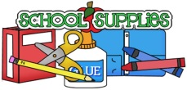
4th Grade Supply List
Reyes Elementary
2016-2017

- 7 composition notebooks (no spirals)
- 3 folders with prongs and pockets
- 2 glue bottles or two packs of glue sticks
- 1 small school box
- 2 jumbo book covers
- 1 box of multi-color pencils
- 1 box of Crayola’s (optional)
- 1 box of thin markers
- 1 pack of EXPO markers
- 2 yellow thin high-lighters
- 2 boxes of pencils (mechanical allowed with special guidelines)
- 1 pencil sharpener with lid
- 1 pair of scissors
- 1 ruler
- 3 packs of college ruled paper
- 1 ream of colored paper (preferably bright colored)
- 4 boxes of Kleenex
- 2 bottles of germ-x
- 2 tubs of Clorox wipes
- Ziploc Bags
- Girls 1 quart
-boys 1 gallon
- 1 pair of headphones
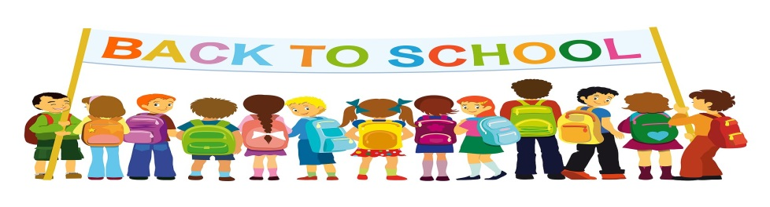

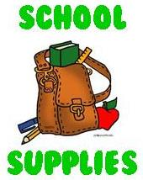
Reyes Elementary
5th Grade Supply List
Escuela Primaria de Reyes
Lista de útiles para 5°grado

- 3 packages of #2 pencils (12 count or higher) | - Tres paquetes de lápices #2 de doce o más
- 4 packages wide ruled loose leaf paper | - Cuatro paquetes de hojas sueltas (Wide rule)
- 1 pencil sharpener | - Un sacapuntas
- 1 box of Crayola Crayons or Colored Pencils | - Una caja de colores o lápices de color
- 1 bottle of Elmer’s Glue | - Una botella de pegamento Elmer’s
- 4 glue Sticks | - Cuatro barras de pegamento
- 1 pair of sturdy scissors | - Un par de tijeras robustas
- 1 ruler | - Una regla
- 3 boxes of Kleenex | - Tres cajas de Kleenex
- 3 folders with pockets (any colors) | - Tres folders con bolsillas (Cualquier color)
- 6 single subject notebooks-wide ruled | - Seis cuadernos de tema único – ancho
- 6 composition books | - Seis libros de composición
- 1 school box | - Una caja escolar
- 5 highlighters | - Cinco marcadores
- 1 pair earbuds or earphones | - Un par de audífonos o auriculares

Supplies may need to be replenished sometime during the year. We will notify you by memo as needed.
Los útiles necesitan ser remplazados en algún momento durante el año escolar. Se le notificara por nota según sea necesario.

Reyes Elementary School

Supply list for Music:

1 ream of white paper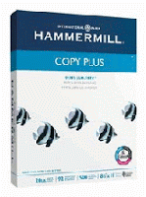
1 large box of tissue paper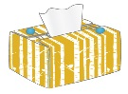
1 bottle of hand sanitizer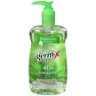
4th & 5th grade – 1 black 1” three ring binder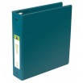

Lista de útiles para la clase de música:

Un paquete de papel blanco
Una caja grande de pañuelos de papel
Una botella de desinfectante para manos
4˚ y 5˚ grado – Una carpeta de tres anillos de una pulgada

